[ Insert official UPAEP logo ]
UPAEP · Decanato de Ingenierías
EVIDENCE — US12-T2
Implement severity classification and display
SmartGreenAI: Cilantro Crop

1. Task information
Task ID | US12-T2
User Story | US-12 — Classify alerts by severity
Sprint | Sprint 3 (2026-10-12 – 2026-10-30)
Week | Week 2
Responsible | Carlos Ramirez Mendoza
Peer reviewer | Jorge Velez Delgado
Planned / actual hours | 2.5 h / 2.5 h
Completed on | October 23, 2026
Status | Done

2. Task description
Calculate the severity when the alert is created and upgrade it if the deviation grows while the alert is open. Show a badge with color, icon and text in the alerts panel.

3. Completion conditions
✓ Condition 1: Every new alert has a severity.
How it was verified: Every new alert gets a severity when it is created: SM-01 at 58.5 % → LOW, TMP-01 at 27 °C → MEDIUM, HUM-01 at 44 % → HIGH.
Every alert created in the test has a severity (3 rows; US12-T2_Implement_Severity_Classification_Display_3.csv)
id | sensor_id | type | severity | deviation_pct | status
alr-38acfe77ee56 | SM-01 | LOW | HIGH | 29 | RESOLVED
alr-4c6c388f4e24 | TMP-01 | HIGH | MEDIUM | 20 | RESOLVED
alr-a0d75b8b79b4 | HUM-01 | LOW | HIGH | 30 | RESOLVED
SQL: SELECT id, sensor_id, type, severity, deviation_pct, status FROM alerts WHERE id = ANY($1)
✓ Condition 2: Severity is upgraded when the deviation grows.
How it was verified: While the SM-01 alert was open, the soil kept drying and the same alert was upgraded:
Severity upgrade of one open alert
Reading | Deviation | Severity of the alert
58.5 % | 7.5 % | LOW
56.5 % | 17.5 % | MEDIUM
54.2 % | 29 % | HIGH

server/src/modules/alerts/service.js — lines 12–25
* upgraded while the alert stays open (US12-T1, US12-T2)
*/
const db = require('../../db');
const settings = require('../../utils/settings');
const daylight = require('../../utils/daylight');
const { notFound, badRequest } = require('../../middleware/errors');
const { logSystem } = require('../../utils/logger');
/** Human-readable label per sensor type, used in the alert message (NFR-06). */
const VARIABLE_LABEL = {
temperature: 'air temperature',
air_humidity: 'relative humidity',
soil_moisture: 'soil moisture',

✓ Condition 3: The badge shows color and text.
How it was verified: The badge shows colour, icon and text (never colour only).
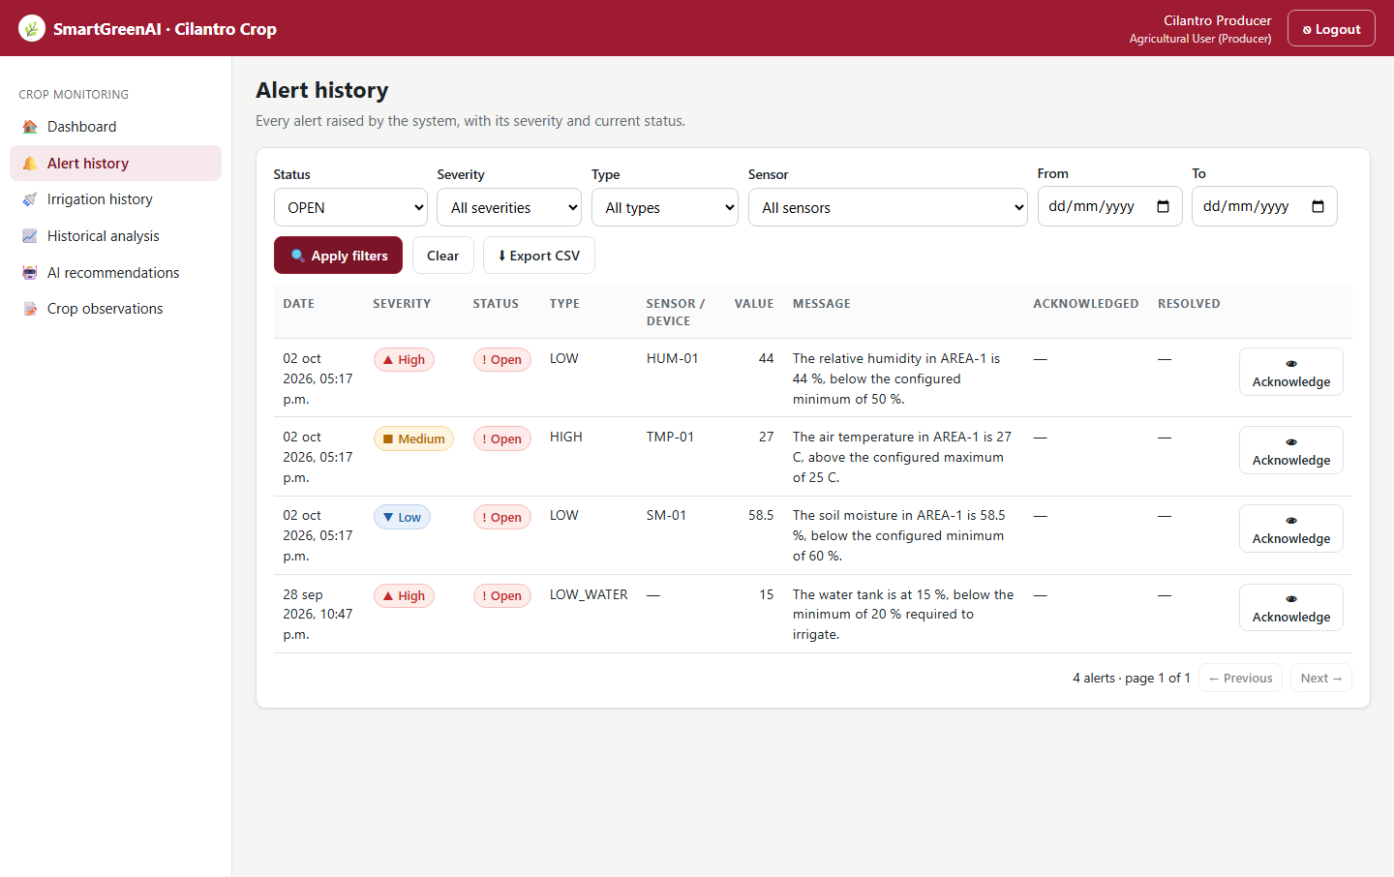
Figure US12-T2-1. Alert history filtered to OPEN alerts: the three severity levels Low (▼ blue), Medium (■ orange) and High (▲ red), each with colour, icon and text. (US12-T2_Implement_Severity_Classification_Display_1.png)
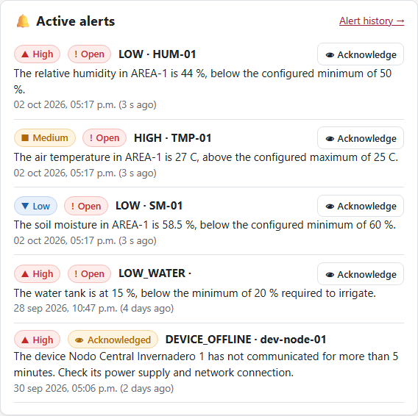
Figure US12-T2-2. The same three alerts in the dashboard alerts panel. (US12-T2_Implement_Severity_Classification_Display_2.png)
public/js/ui.js — lines 78–82
export function severityBadge(sev) {
if (sev === 'HIGH') return badge('danger', 'High', '▲');
if (sev === 'MEDIUM') return badge('warn', 'Medium', '■');
return badge('info', 'Low', '▼');
}

✓ Condition 4: Evidence: Screenshot showing alerts with the three severity levels.
How it was verified: Screenshots with the three severity levels (Figures 1–2).

4. Attached files
- US12-T2_Implement_Severity_Classification_Display_1.png
- US12-T2_Implement_Severity_Classification_Display_2.png
- US12-T2_Implement_Severity_Classification_Display_3.csv
- US12-T2_Implement_Severity_Classification_Display_4.sql

5. Traceability
Related requirements | FR-14
Implementation | alerts svc deviationPercent(), classifySeverity(), upgrade while open; ui.js severityBadge() (colour + icon + text)
Verification | integration/thresholds-alerts.test.js (LOW → MEDIUM upgrade)

6. Sign-off
Role | Name | Date | Signature
Responsible | Carlos Ramirez Mendoza | October 23, 2026
Peer reviewer | Jorge Velez Delgado | October 23, 2026
Product Owner acceptance | Alexis Enrique Valle Parra | October 23, 2026
Approval record: Daily Meeting 3 of Sprint 3 (Monday, October 26, 2026), Scrum board: "Tasks moved to Done last week: US11-T3, US11-T4, US11-T5, US12-T2, US13-T3, US15-T6, US15-T7, US16-T3, US16-T4, US17-T2, US19-T4, US19-T5, US19-T6."

